**Letter of Transmittal**

Date: October 21, 2013

To: Dr. Jeffrey Ritchie, Professor of Technical Communications

Lebanon Valley College

From: Matthew Healy, DCOM 280

Lebanon Valley College

Subject: Instruction Assignment: Constructing a Marshmallow Gun

Attached are the instructions and the usability test report for “ The Construction of a Marshmallow Gun”. On October 18,2013 the usability testing was completed on the effectiveness of the instructions and how well they serve the audience they were designed for. The instructions are designed for individual with no prior knowledge of how to construct the product, and between the ages of nine and eighteen. However, the written instructions are formatted for an older audience, as an adult should be present during the construction of the Marshmallow Gun.

The goal of the instructions was to have a clearly defined start, and meet the goal by the end state. The start state, as listed above, is for a younger and inexperienced individual. While the end state consists of three parts. The individual should first be able to complete the instructions and create a fully functional product. Secondly, be able to construct the product with little or no help from the instructions. And lastly, be able to enjoy the building process, as having fun while building a product is the main reason for building the product in the first place.

The main purpose of the instructions is to provide an individual or groups of individuals with an easy to make, and inexpensive project that is “something different”. These instructions target mainly younger children, and groups such as Boy Scouts, as it is a simple process to build something that a child could use physically. The construction of the Marshmallow Gun provides the individual with a product that is unusual, and isn’t harmful to objects if it were to be shot at something. Adult Supervision is highly recommended for the construction of the project, and also during the usage of the Marshmallow Gun to ensure safety.

The instructional video for “The Construction of a Marshmallow Gun” is placed on Vimeo.com, and can be found through the search link, or my profile. However, within the next six months, the instructional video will also be able to be found on Youtube.com.

**Constructing a Marshmallow Gun**

**Preface:**

-Before starting the construction of your Marshmallow Gun, I highly recommend placing newspaper on the surface that you will be using to build your gun on, so that you don’t damage any surrounding objects. I also highly recommend building and decorating your gun in an area that you are able to not worry about damaging anything, as spray paint spreads very easily and can cause damage to other objects.

**Acquire Materials**

-To build your Marshmallow Gun, you will need the following:

-1/2” PVC pipe

-2 Elbow fittings

-2 T fittings

-2 End caps

-Saw

-Ruler

-PVC Glue

-Decorations (Spray paint, stickers…)

**Step 1: Marking the Cuts**

-In order to have a proper functioning marshmallow gun, you’ll need to cut the pieces to the following measurements:

-3” piece x 4

-4” piece x 1

-5” piece x 1

-10-12” piece x 1

**Step 2: Cutting the pieces ADULT SUPERVISION REQUIRED**

-Very carefully make clean, straight cuts to the appropriate lengths that we just marked out. The Cutting stage is crucial to the marshmallow gun working correctly and should be done slowly and very carefully.

**Step 3: Aligning the PVC**

-After all the cuts and cleaning of the PVC are made, layout the pieces as seen on the diagram. At this point if something looks “off”, or doesn’t look like it fits properly, you can go back and make another cut to ensure that they all fit properly. See picture 1 on the picture page.

**Step 4: Cleaning the PVC**

-After the cuts are made, look inside the PVC where we made the cuts. There will be small fragments and pieces hanging on to the PVC. These pieces are very toxic and dangerous if the individual were to inhale them and need to be cleaned out. By taking sand paper, you can clean off the pieces so the PVC is safe to use. See picture 2 for details.

**Step 5: Glue**

-This step requires adult attention and supervision. Apply the PVC glue to the fitting and PVC pipe, ensuring that all the parts fit together correctly. Lather the glue around the PVC that will be entering the fitting, then carefully compress the two pieces together. Once the glue is applied however, the pieces will NOT come apart again, so be very careful!

**Rest**

-Make sure you let the glue rest and dry to ensure the safety of using the marshmallow gun. The resting stage should take anywhere from 10 to 25 minutes to completely dry.

**Step 6:Preperation for Paint**

* Before starting the painting, if possible find an area outside on the ground that can be painted on. The easiest way to keep the gun stable is to place a pen or pencil about half way up, leaving the other half out of the ground. Next, place the barrel of the gun down, on top of the pen or pencil so that it is sitting vertically without falling over. Now you’re ready for paint!

**Step 7: Painting!**

* Now, with adult supervision, you can start to paint. Standing back about a foot from the gun, spray the gun with whichever color or colors you chose so that it looks just how you would like.
* When finished, leave the gun to sit for a minimum of 20 to 30 minutes to ensure that the paint is fully dry.

**Fire Away!**

-Now the paint and glue has dried on your Marshmallow Gun, its time to fire! Place 1 mini marshmallow in the small barrel on top, so that both your hands are holding the bottom handles comfortably. Next, take a deep breath, and blow! The Marshmallow should fly through the PVC and out the barrel at the target you were aiming at!

**Pictures**

1.

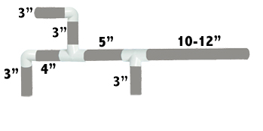

2.

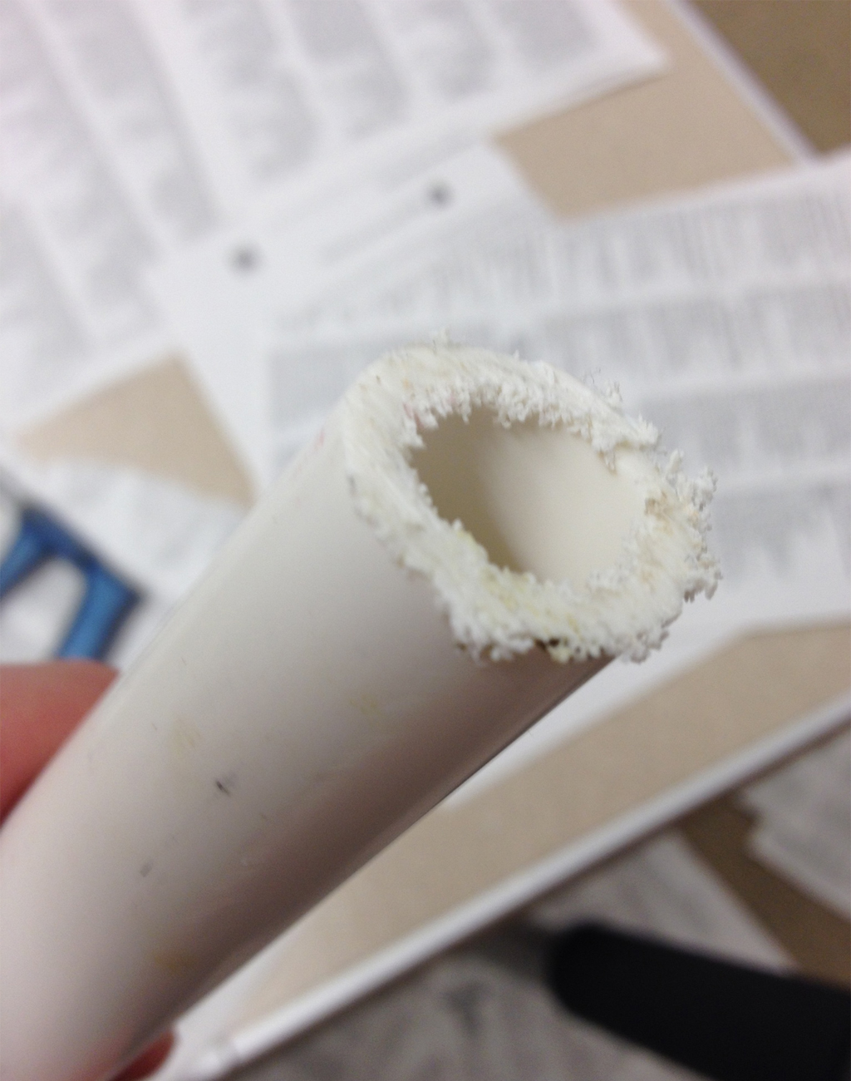

**Test Plan**

**Goals of the test:**

The purpose of the test is to critique how well the instructions can be understood and followed through with encountering minimal problems. I mainly want to focus on the language, and efficiency of the individual to comprehend what I’m saying while the video is playing; not focusing on the text on the screen as much (2nd resort). Mainly I want to ensure that the test subject is able to accomplish the task in a reasonable time.

**Users:**

The instructions are structured for individuals between the ages of 9 and 18. However, the written instructions are written in a manner that is more suitable for an adult, as a younger child will require an adult during the building process. The usability test is going to be run with one test subject at the age of 18. The overall goal for this user is going to be able to complete the building process (not decorating) in less than 30-45 minutes. The individual will be given all the necessary tools to complete the task and is required to not have any prior knowledge of building a Marshmallow Gun in the past. By doing so, the information gathered from the test will provide experiences of a first time user, and will be accurate when critiquing the quality of the instructions.

**Test Task:**

The start state of the testing will be an individual with no knowledge of how to build a Marshmallow Gun and a set of video instructions and supplies. They will be videoed and timed on the completion of their work. The end state will consist of the same individual with knowledge of how to build a Marshmallow Gun, and will be able to build the gun (at least the basic construction) without the instructions the next time they construct the product. The overall goal of the testing is to inform the user, and hopefully allow them to be able to build the product in the future with minimal or no help from the instructions.

**Follow up questions:**

1. Did you encounter any problems during the construction of the Marshmallow Gun?

-“*Yes, just the one step with aligning the pieces together. I wasn’t sure as to what to do with the extra piece when putting it together.”*

1. Were there any steps that seemed misleading or confusing? Be specific.

*-“Like I said, just the one step caused a minor problem.”*

1. Were there any steps that were not needed, or overextended?

*-“No, they all seemed very clear.”*

1. Did you have to restart the video from any point because of missing a step?

*-“Just the one spot, and to pause the video for the construction of the pieces.”*

1. Is there anything else you would want to add to make the instructions more successful for others?

*-“No, the steps seemed very precise and accurate as for what to do.”*

1. How do you feel about the quality (manner) in which the instructions were presented?

*- “Seemed very professional, something that I would see on YouTube.”*

**Data:**

1. Video: visually seeing how the test subject reacts to the video. Expressions, and speaking out loud during the building process will allow me to see how individual feels about the instructions that they may not say later during the questioning.
2. Stopwatch: will allow me to see how long each step took the individual. Whether some steps took longer then others or what steps the individual encountered problems in. Provides an estimated completion time by an individual with no prior knowledge compared to myself (with knowledge) to complete the task.
3. Notes: the notes will provide myself with any questions the individual may ask during the process of the test, and which section of the process they occurred.
4. Supplies: measurement of the PVC piping and the amount of products that were used. This will help with the amount of necessary products needed to complete the task.

**Test Script**

The Building of a Marshmallow Gun

Thank you for agreeing to be part of the testing of building a Marshmallow Gun. With this being said, welcome to the usability testing! The purpose of the testing is to critique the instructions you are being given. There will be a video and stopwatch on during the testing, but this is only for evaluating the instructions as you work your way through them. A usability test is simply a critique of the product provided, not the test taker of the product. You are provided with the necessary supplies you need, all you need to do is follow the instructions as they are shown and have fun! Remember, the usability testing is critiquing the instructions you are provided with, not how well you can build a Marshmallow Gun.

Test Task:

The task of the testing is broken down into two sections. The start state is an individual (you) with no prior knowledge of how to build a Marshmallow Gun. The second section consists of the same individual able to complete the task again with minimal or no help from the instructions once the product is completed. By conducting a usability test, we will be able to see how well our instructions are able to fulfill this task.

Follow up questions:

1. Did you encounter any problems during the construction of the Marshmallow Gun?
2. Were there any steps that seemed misleading or confusing? Be specific.
3. Were there any steps that were not needed, or overextended?
4. Did you have to restart the video from any point because of missing a step?
5. Is there anything else you would want to add to make the instructions more successful for others?
6. How do you feel about the quality (manner) in which the instructions were presented?

**Usability Test Report**

The usability test plan was conducted on the construction of a Marshmallow Gun. The Marshmallow Gun is constructed out of one half-inch PVC pipe and requires materials that can be purchased at a typical hardware store. The target audience for the project is within the ages of nine and eighteen. However, the written instructions are formatted for an adult, as adult supervision is recommended for certain steps during the construction. The time of completion for the project was projected to be less than 45 minutes if the individual were to follow every step of the process. The main goal of the instructions was to provide an enjoyable experience, and for the individual to be able to create the product again if they wanted with minimal help from the instructions.

When the testing began, the subject was given a workspace, all the materials needed, and the video of instructions. Before the testing began, a video camera and a stopwatch were set up to record the time and physical expressions during the testing. The test subject that was used had to have never built a Marshmallow Gun before or ever seen one, to ensure that he was a first time builder of the project.

Once the testing began, the stopwatch was started and the video instructions were played. Through the first few steps, the subject (Spencer Miller) made no errors and followed the instructions without pausing or having to start the video over. However, once reaching the first construction phase of the project, the individual started to encounter problems. He had a problem with the measurement section of the video, as he missed what the measurements were and had to restart the video and pause it in order to have the proper measurements. The video section stating what the measurements were appeared to be to fast, and left him with no time to actually complete the task. This step was projected to only take two or three minutes, but during the testing was recorded at taking almost six minutes to be completed. After going back and pausing the video, the subject was able to construct the proper measurements and move on to the next step.

The individual did encounter another problem however within the next two steps. After the cutting phase was completed, the subject was asked to place the parts in the appropriate spots as seen on the video, but encountered problems when doing so. Off screen he mentioned that he was unsure of what parts to use, as the cutting phase left him with extra pieces that wasn’t demonstrated during the video. The individual asked for help and I stepped in to show him in the video where the pieces were supposed to be placed. After doing so, the subject understood and was able to look at the video, pause the instructions, and put them together himself. After reviewing the video a second time and having help from an outside source he was able to complete the task correctly.

When arriving at the following steps, some of the steps were left out when the testing occurred. The Gluing stage and the Painting stage weren’t used due to the environment in which the testing was provided, however the subject was asked how to go about doing so as the video instructed him. These steps aren’t necessary to the construction of the Marshmallow Gun, but are however beneficial to the performance and aesthetics, but aren’t necessary. The individual was able to demonstrate the proper way to glue pieces and stabilize the gun with only pausing the video for demonstrations purposes.

When following the completion of the instructional phase the subject was asked questions about the instructions he was provided with. He had stated that the only problem that he had real trouble with was with the step about organizing the pieces. He had added that maybe that specific step should be emphasized more to ensure that pieces are placed in the appropriate spot. The rest of the video in which he had to pause to complete he stated was fine and demonstrated that this section would take a couple minutes and should be paused. Once the questioning was completed the data was taken and recorded with the notes that I had written during the testing. He had completed the project in 20 minutes, which proved that if he had followed the steps about gluing and painting the PVC, it would have taken him around 45 minutes to complete the project.

By doing the usability testing, the video showed flaws that could affect the overall efficiency of the product. The organization step and measurement step need to be re-shot, so that the video is more precise as to where the pieces go and how long each piece is. The subject did mention though that the remaining steps were very precise and easy to follow, and seemed much like something he would see on YouTube. Since we did not glue the pieces, once the testing was completed and I had taken away the computer, I asked the subject to take the gun apart and build it again. The construction is the most vital part of the project and he was able to do so without any hesitation and finished in just a few minutes.

The testing was very successful in showing that the instructions serve their overall purpose. The subject was within the audience that the instructions were designed for, and was able to achieve the goal of constructing a functional Marshmallow Gun. The subject was also able to achieve the overall goal of repeating the process again with no help from the instructions, and most importantly had fun while doing so. With this being said, minimal adjustments could be made to ensure that the instructions are flawless, but have been proven that they are able to meet the requirements of constructing a Marshmallow Gun.